|  |
| --- |
| Harcourt Mountain Bike Park |
| Project update, February 2017 |

Situated next to Mount Alexander Regional Park, the Harcourt mountain bike park (HMBP) will provide up to 34 kilometres of dedicated mountain bike trails and magnificent views alongside a natural forest setting.

The project is estimated to inject $9.8 million into the local economy, attracting 100,000 visitors each year and generate local jobs.

Built to International Mountain Bicycling Association standards, the park will be consistent with future development plans for the Harcourt area while improving the site's environmental value.

Design and works

The site of the mountain bike park is on the old plantation site on the west side of Mount Alexander.

The majority of the car parking is planned to be catered for in the Harcourt township and riders will be encouraged to support local businesses and take the short ride to the trail head on the mountain. There will also be limited parking provided at the mountain bike park.

The Victorian Government is not purchasing private land to build a car park.

The park will not be fenced and will be open to all recreational users including walkers and horse riders.

Three new barbeques have recently been installed at ‘The Oaks’ replacing older styles and comply with fire regulations. Toilet facilities will also be provided for the mountain bike park and will be located where they can also be accessible to users of ‘The Oaks.’

The community will also notice that works will begin soon to upgrade the fire access track.

Tender process

Tender submissions for the trail construction are being evaluated and DELWP expects to have a contractor on board in early April.

Forrest tour

On 13 January 2017, the Community Reference Group and the Project Control Group visited the Forrest Mountain Bike Trails, touted to be one of the premier mountain bike destinations in Victoria, to learn about the successes and challenges of building a world class mountain bike park.

The town has significantly benefitted economically and socially since the mountain bike park was built approximately 10 years ago.

Also of note, was that mountain bike riders are very willing to ride the three kilometres from town to the trail head. This is approximately the same distance from the Harcourt township to the proposed trail head of the Harcourt mountain bike park.

Community consultation

DELWP and its partners held a Community Information Session on 8 February 2017 at the Harcourt Leisure Centre. More than 40 community members attended the event. It was an importante opportunity for community members to ask questions and give their feedback on the early stages of the project.

Community members are excited about the project and are expressing their support for the many expected benefits.

Many residents told us that they supported the project and look forward to its economic benefits to the Harcourt community.

There is strong support to retain access to ‘The Oaks’ and for the park to be available to a range of existing compatible recreational users.

There was also a number of people concerned about ensuring safe rider access to and from the mountain. DELWP and Mount Alexander Shire staff are working together to review various options before discussing with the community a preferred route.

Russell Manning, Project Manager, HMBP, has also met and will continue to meet with interested people to gather ideas, listen to opinions, provide progress updates and discuss this exciting project.

The next opportunity to have your say, get more information or ask questions about the project will be at the 2017 Harcourt Apple Fest on 11 March in Harcourt. Look out for the Harcourt Mountain Bike Park stall and be ready to share your ideas.

Please contact Russell Manning at 5430 4444 or [harcourtmbp@delwp.vic.gov.au](mailto:harcourtmbp@delwp.vic.gov.au) for more information or any enquiries on the project.

Project Timelines

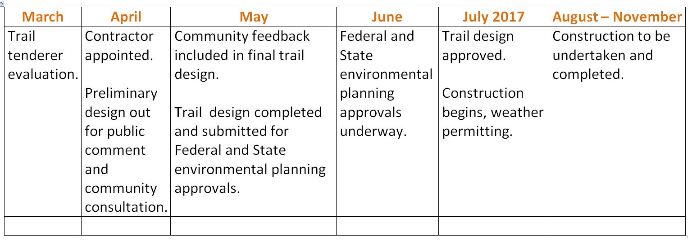

Get involved

Community members are encouraged to register their interest to receive project updates and become involved in future consultation and engagement opportunities.

Register your interest at [harcourtmbp@delwp.vic.gov.au](mailto:harcourtmbp@delwp.vic.gov.au) or call DELWP on 136 186.

For more information and updates, visit www.delwp.vic.gov.au/harcourt-mbp

|  |  |
| --- | --- |
| The State of Victoria Department of Environment, Land, Water and Planning 2017  LogoThis work is licensed under a Creative Commons Attribution 4.0 International licence. You are free to re-use the work under that licence, on the condition that you credit the State of Victoria as author. The licence does not apply to any images, photographs or branding, including the Victorian Coat of Arms, the Victorian Government logo and the Department of Environment, Land, Water and Planning (DELWP) logo. To view a copy of this licence, visit http://creativecommons.org/licenses/by/4.0/  Printed by Department of Environment, Land, Water and Planning  Disclaimer  This publication may be of assistance to you but the State of Victoria and its employees do not guarantee that the publication is without flaw of any kind or is wholly appropriate for your particular purposes and therefore disclaims all liability for any error, loss or other consequence which may arise from you relying on any information in this publication. | Accessibility  If you would like to receive this publication in an alternative format, please telephone the DELWP Customer Service Centre on 136186, or via the National Relay Service on 133 677 [www.relayservice.com.au](http://www.relayservice.com.au). This document is also available on the internet at [www.delwp.vic.gov.au](http://www.delwp.vic.gov.au)/harcourt-mbp |